### 

### 

### 

### 

### **Slug: top-10-cold-email-automation-tool**

### **Meta Description: Boost outreach and improve conversions with top** 10 cold email automation tools of 2025.

### **Top 10 Cold Email Automation Tools For Sales Outreach in 2025**

Hello 👋 So, you are here, which means, you are looking for the **best cold email automation tools of 2025**

You may want to contact future customers, hire new employees or maybe just save your sales team some grunt work.

Excellent! You are in the right place, whatever your objective is.

Here's the deal. One of the best strategies to contact prospects has always been **cold emailing.**

But let’s be honest—crafting, scheduling, and sending hundreds (or thousands) of cold emails manually? Not fun.

That’s where **cold email automation tools** come in. They simplify the whole procedure while guaranteeing your emails don’t come out as spammy. So, buckle up! Let’s review the top **10 cold email automation tools of 2025.**

**SalesRobot**

Let’s talk about **SalesRobot.** Cool name, right? This one’s ideal for sales teams looking to scale their outreach without compromising on quality of the email

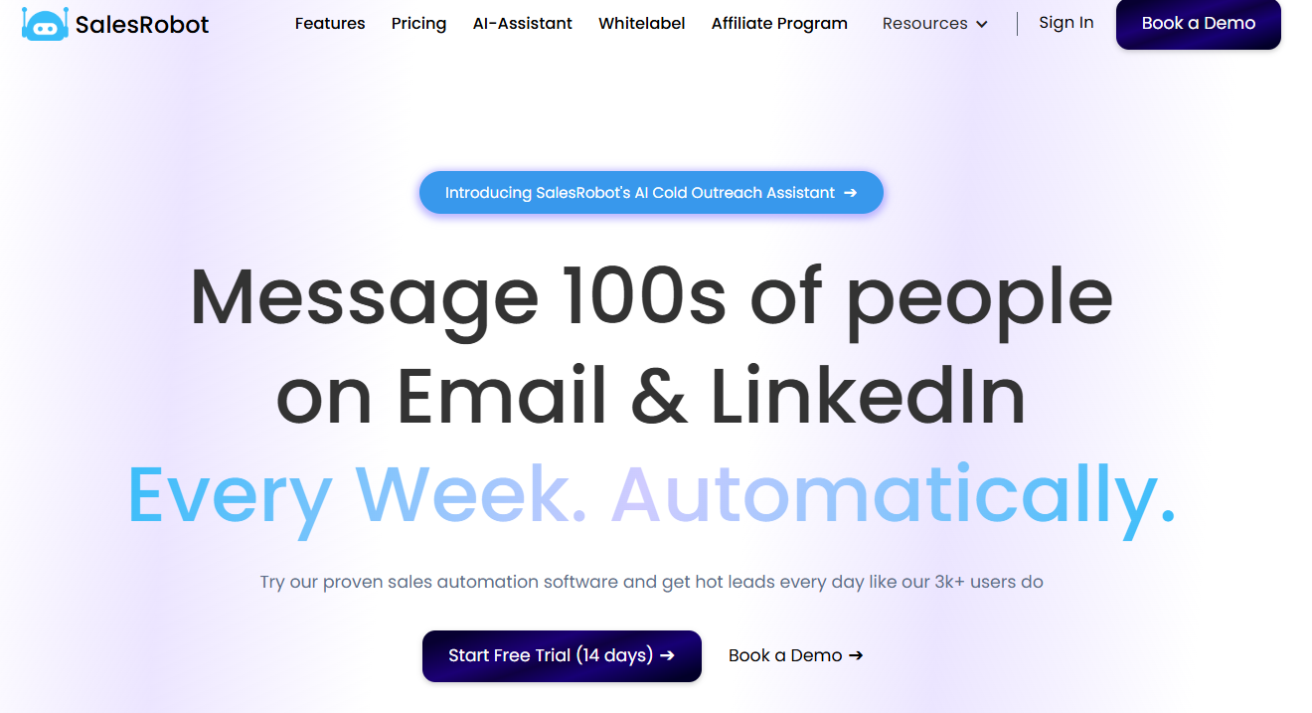

**Here’s why it works:**

* **Automation + AI:** Combines traditional sequence automation with AI powered custom variables for smarter campaigns so that the emails don’t look automated.
* **CRM integration:** Syncs effortlessly with popular CRMs like HubSpo, Pipedrivet and Salesforce.
* **LinkedIn Automation**: Cold email reply rates are at an all time low (<1% on average). SalesRobot has LinkedIn Automation capabilities that can help you reach out to the same person and get a much higher response rate (8% on average)
* **Detailed analytics:** Get insights into what’s working (and what’s not).

**Pricing:** **SalesRobot Starter Plan**

* **Price:** $99/month ($79/month with annual discount)
* **Features:**
  + 1000 connection requests, 600 follow-ups, 800 InMails, 600 cold emails/month
  + Unlimited team members
  + LinkedIn/Sales Navigator & CSV import
  + AI-written messages, personalization, auto-pausing on reply on cold email or LinkedIn
  + A/B testing & CRM integrations
  + 14-day free trial

This plan is designed for small businesses looking to leverage LinkedIn and cold email for sales outreach.

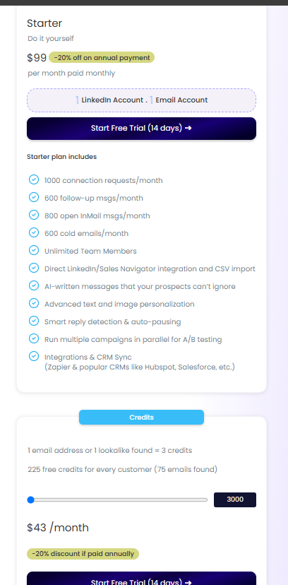

What customers are saying:  
*“It's whole system is clearly broken into steps and sections. While they UI can get busy, it's still easy enough to navigate and make campaigns. I rely on this a lot at making first contact through LinkedIn or email.*

*Worth every cent and a great compliment to your sales or CRM.’’*

<https://www.g2.com/products/salesrobot/reviews/salesrobot-review-10348385>

**Limitations:**Some users report occasional glitches in the analytics section. But hey, no tool is perfect.

## 

## 

## **Saleshandy**

Let’s kick things off with a big name. **Saleshandy** is one of the most popular tools out there for cold email automation. Why? Well, it’s got the right mix of simplicity, efficiency, and affordability.

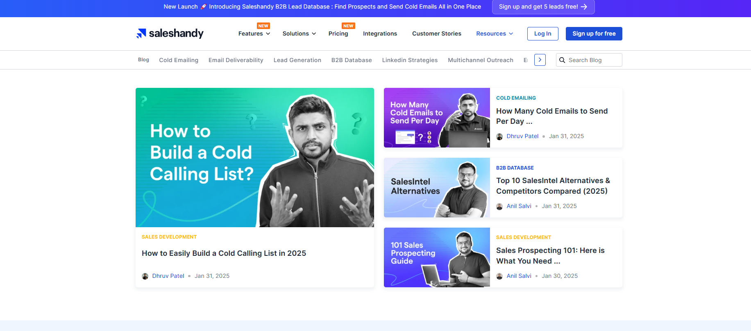

What makes Saleshandy shine?

* **Personalized email campaigns:** Craft and schedule highly targeted emails. Perfect for grabbing attention.
* **Advanced analytics:** You’ll get detailed reports on open rates, click-through rates (CTR), and reply rates.
* **A/B testing:** Not sure what works? Test subject lines, email content, and more to improve your outreach.
* **Integrations:** Syncs with Gmail, Outlook, and other email providers.

**Pricing:** Starts at **$25/month** per user for outreach starter and goes up to **$219 for Outreach Scale Plus 100k plan**. Not bad, right? And the higher-tier plans give access to unlimited tracking and campaigns.

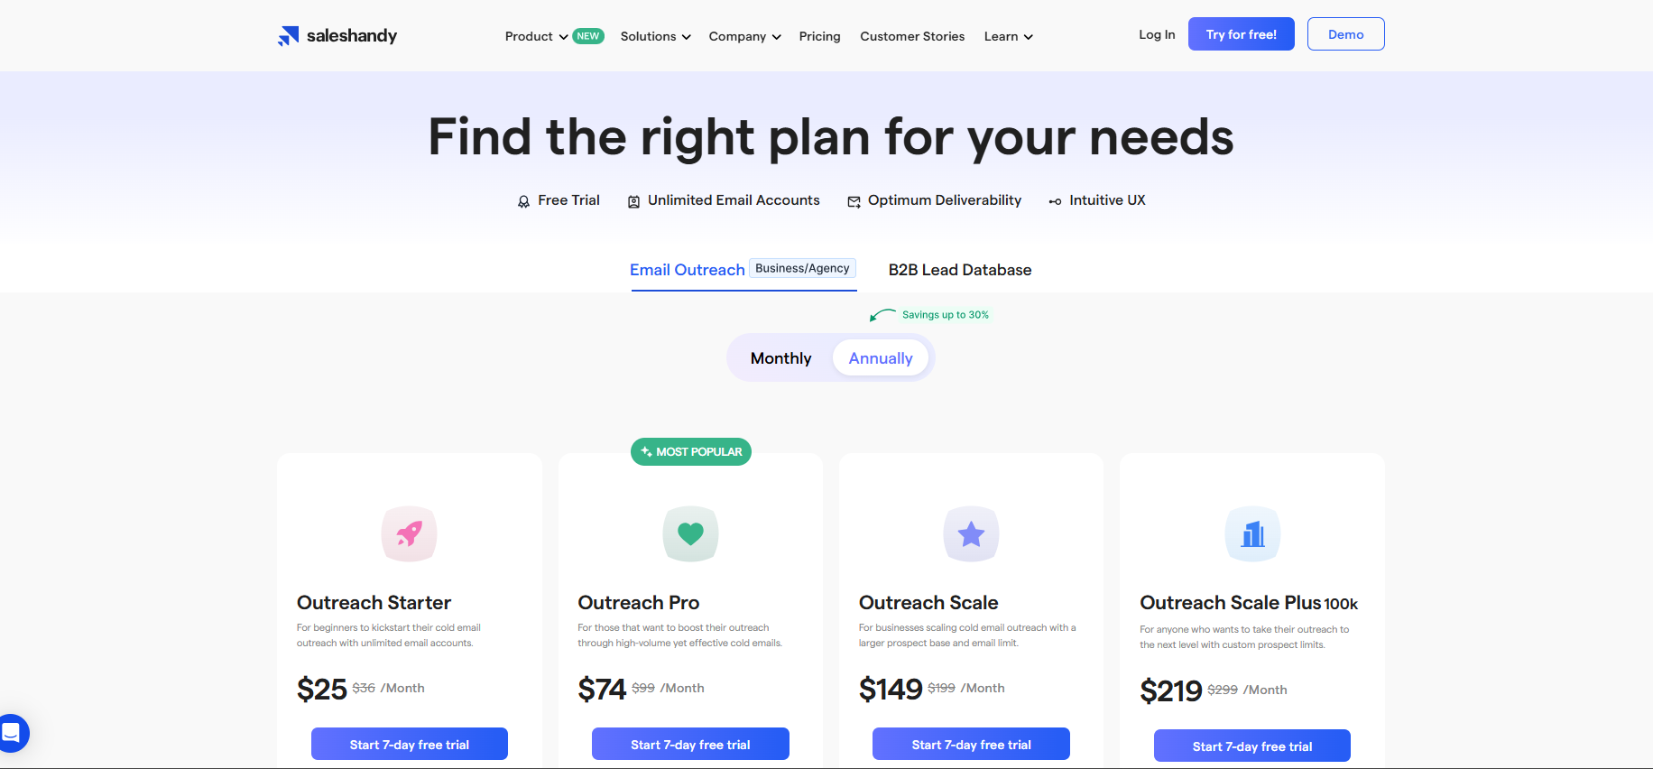

**What customers are saying:**“Saleshandy is a game-changer! The analytics helped me tweak my campaigns, and my reply rate doubled.”

**Limitations:**Sure, it’s great, but there’s no LinkedIn Automation. If you’re a sales team looking for a way to reach out to prospects on both cold email and LinkedIn , you might need additional software.

## **Woodpecker**

Alright, next up: **Woodpecker.** If you’re a fan of minimalistic tools that *just work*, you’re gonna love this one. It’s perfect for B2B outreach.

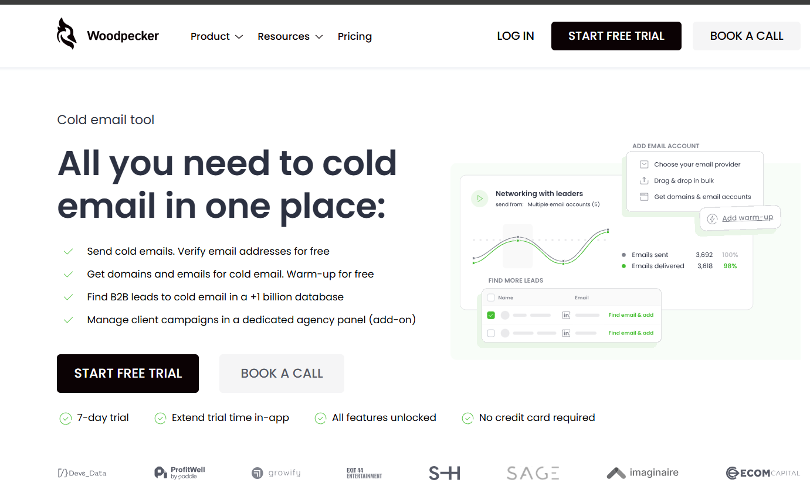

Why is Woodpecker worth checking out?

* **Simple yet powerful UI:** Its interface is super intuitive. No steep learning curve here!
* **Follow-up automation:** You can schedule follow-ups that actually feel human. It’s like having a nice personal assistant.
* **Deliverability:** Woodpecker ensures your emails hit the inbox, not the spam folder.
* **Team collaboration:** Coordinate campaigns across your team seamlessly.

**Pricing:** Plans start at **$20/month** per slot for the starter pack. (Pro tip: Grab annual billing to save a few bucks up to **33%** **off**.)

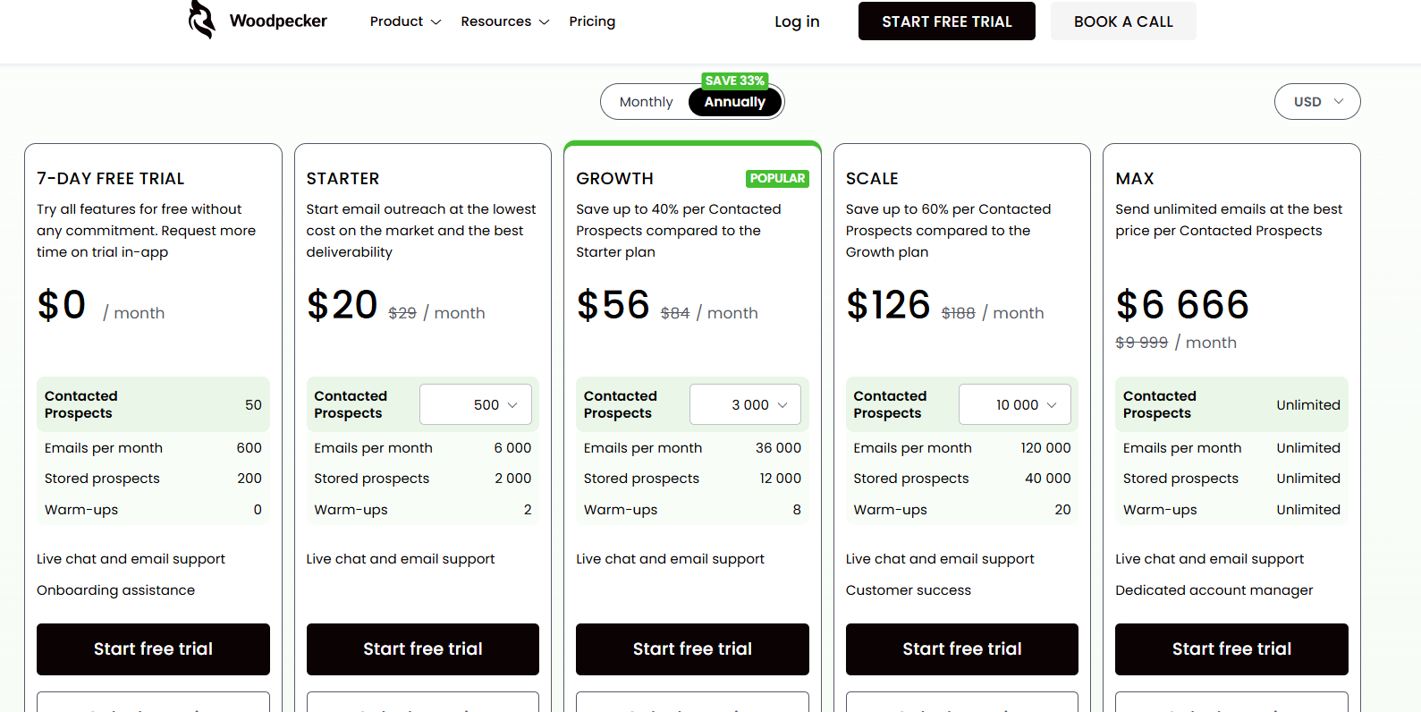

**What customers are saying:**“Woodpecker has become our go-to for cold outreach. It’s reliable and keeps deliverability issues at bay.”

**Limitations:**It’s slightly pricier than its competitors (even after they recently switched to an unlimited email account pricing model), and some users wish it had a wider range of integrations.

## **Smartlead.ai**

Looking for something *smart*? Let me introduce you to **Smartlead.ai.** This tool is a fast rising star in the cold email game, and for good reason.

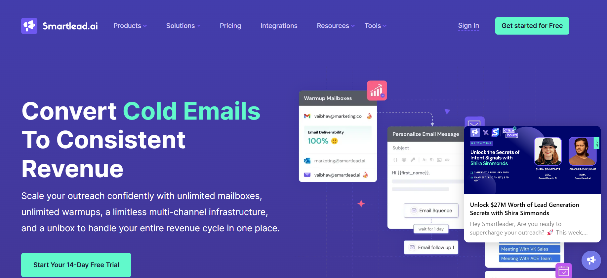

**Standout features?**

* **Multiple inboxes:** Scale your campaigns by managing outreach from multiple email addresses.
* **Smart rotation:** Keeps your domain safe by spreading emails across accounts.

**Pricing:** Starts at **$32/month for yearly plans** .Cheap and best

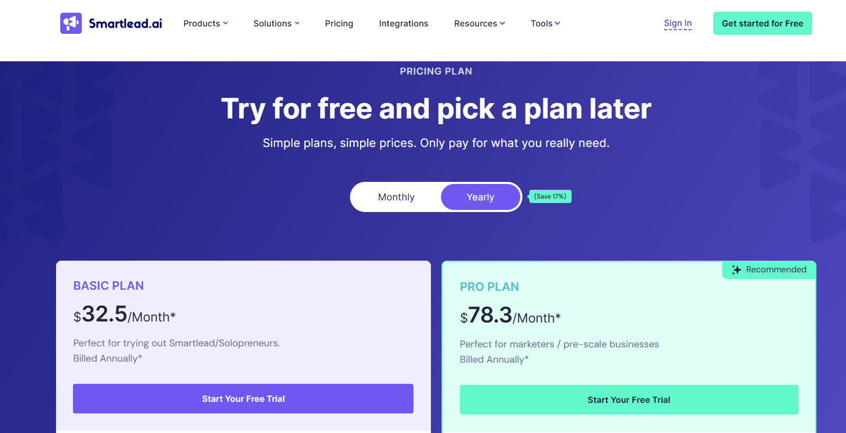

**What customers are saying:**“Smartlead.ai is the future of email automation. Our email outreach has scaled to the next level with them ”

**Limitations:**The dashboard might feel overwhelming for first-time users. But hey, you’ll get the hang of it after a bit of exploring.

## **Instantly.ai**

Oh yes, we’re on to **Instantly.ai.** This tool is all about speed and simplicity, living up to its name.

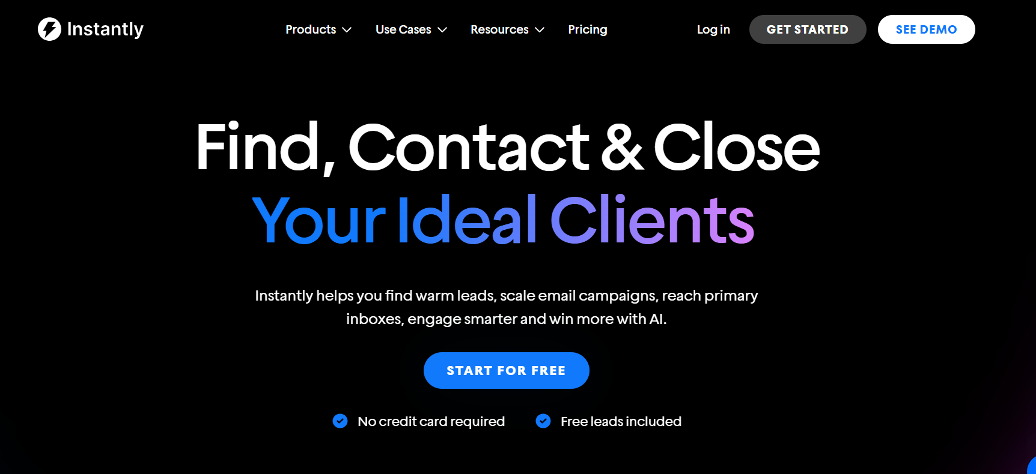

**Why should you care?**

* **Effortless setup:** Seriously, you can get started in *minutes.*
* **Unlimited accounts:** Manage multiple domains and email accounts without breaking a sweat.
* **Data-driven campaigns:** Get real-time insights into how your campaigns are performing.
* **Deliverability:** Keeps your email reputation intact cause you’re rotating across multiple domains and inboxes just like Smartlead.

**Pricing:** Starts at **$30/month for yearly plans.** Affordable, right?

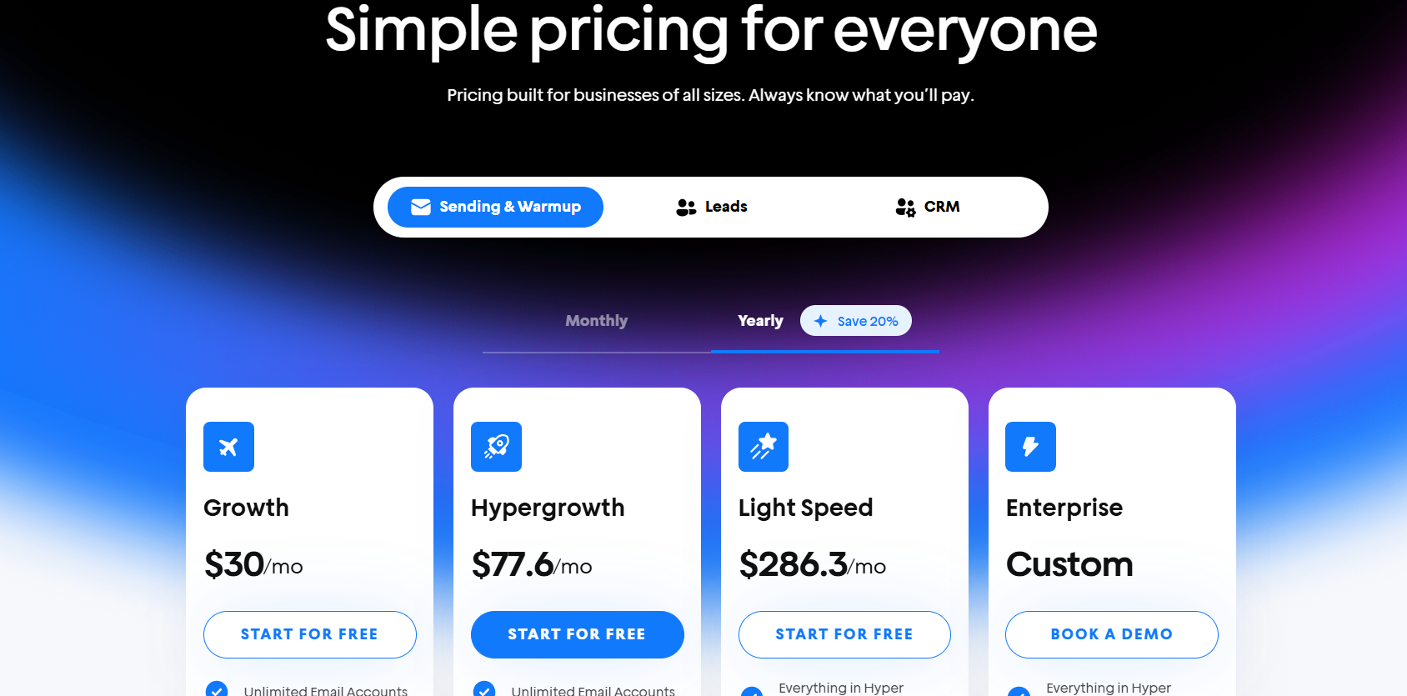

**What customers are saying:**“Instantly.ai is hands-down the easiest tool I’ve ever used. Plus, their customer support is top-notch.”

**Limitations:**While it’s easy to use, you need to learn the ins and outs of cold email deliverability to be effective at using it . So, you might feel a little restricted if you're a total newbie to cold email.

## **Lemlist**

Ah, good ol’ **Lemlist.** You've probably heard of this one if you’ve been in the cold email space for a while. It’s a favorite for creating emails with a bit of personality.

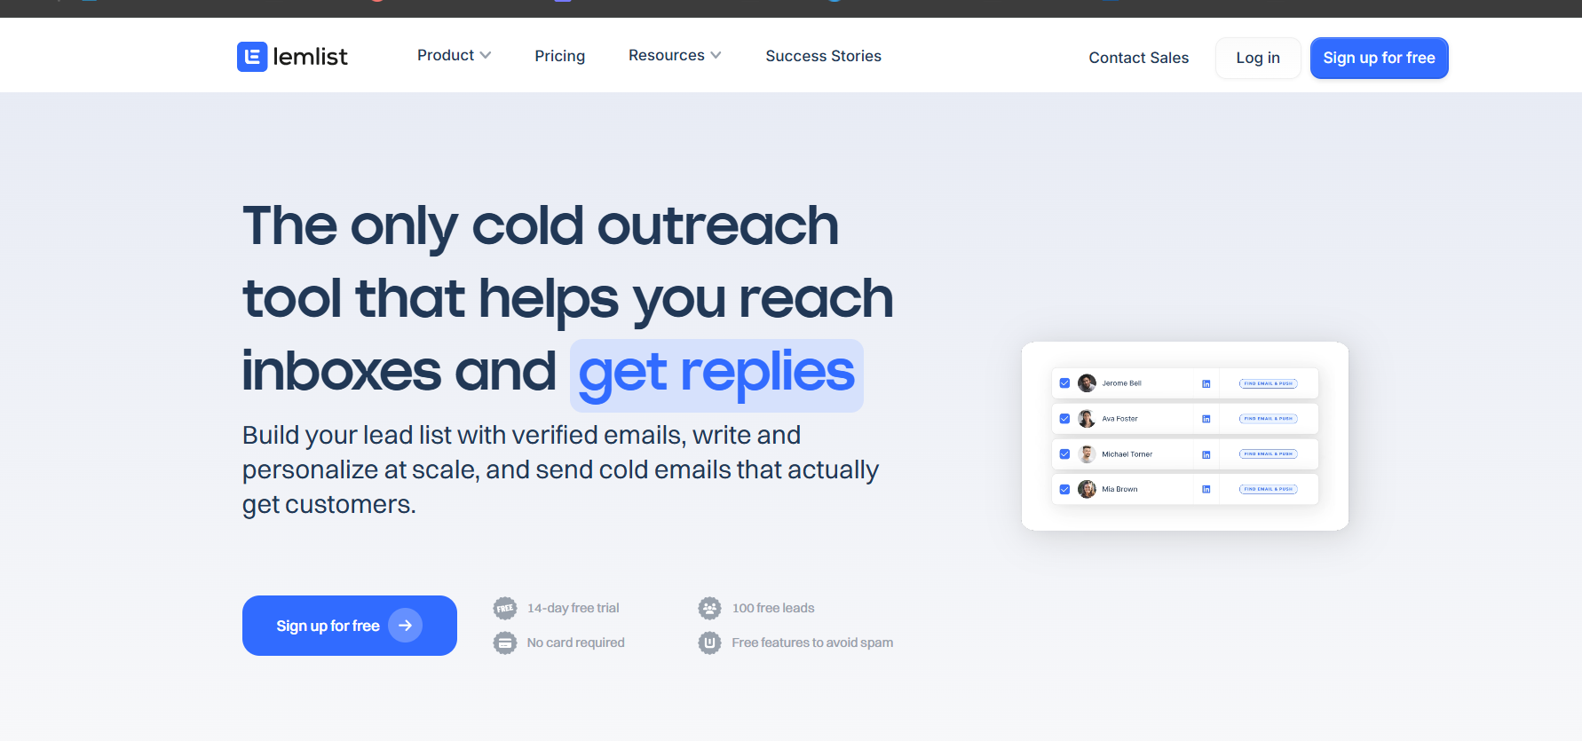

**What’s so special about Lemlist?**

* **Custom image personalization:** Add names, logos, or even custom messages to images in your emails.
* **Engagement tracking:** See who’s opening, clicking, and replying to your emails.
* **Templates galore:** Tons of pre-made email templates to save you time.

**Pricing:** Plans start at **$79/month** for the multichannel expert plan yearly with a 14-day free trial**.** A bit steep, but hey, those features are worth it.

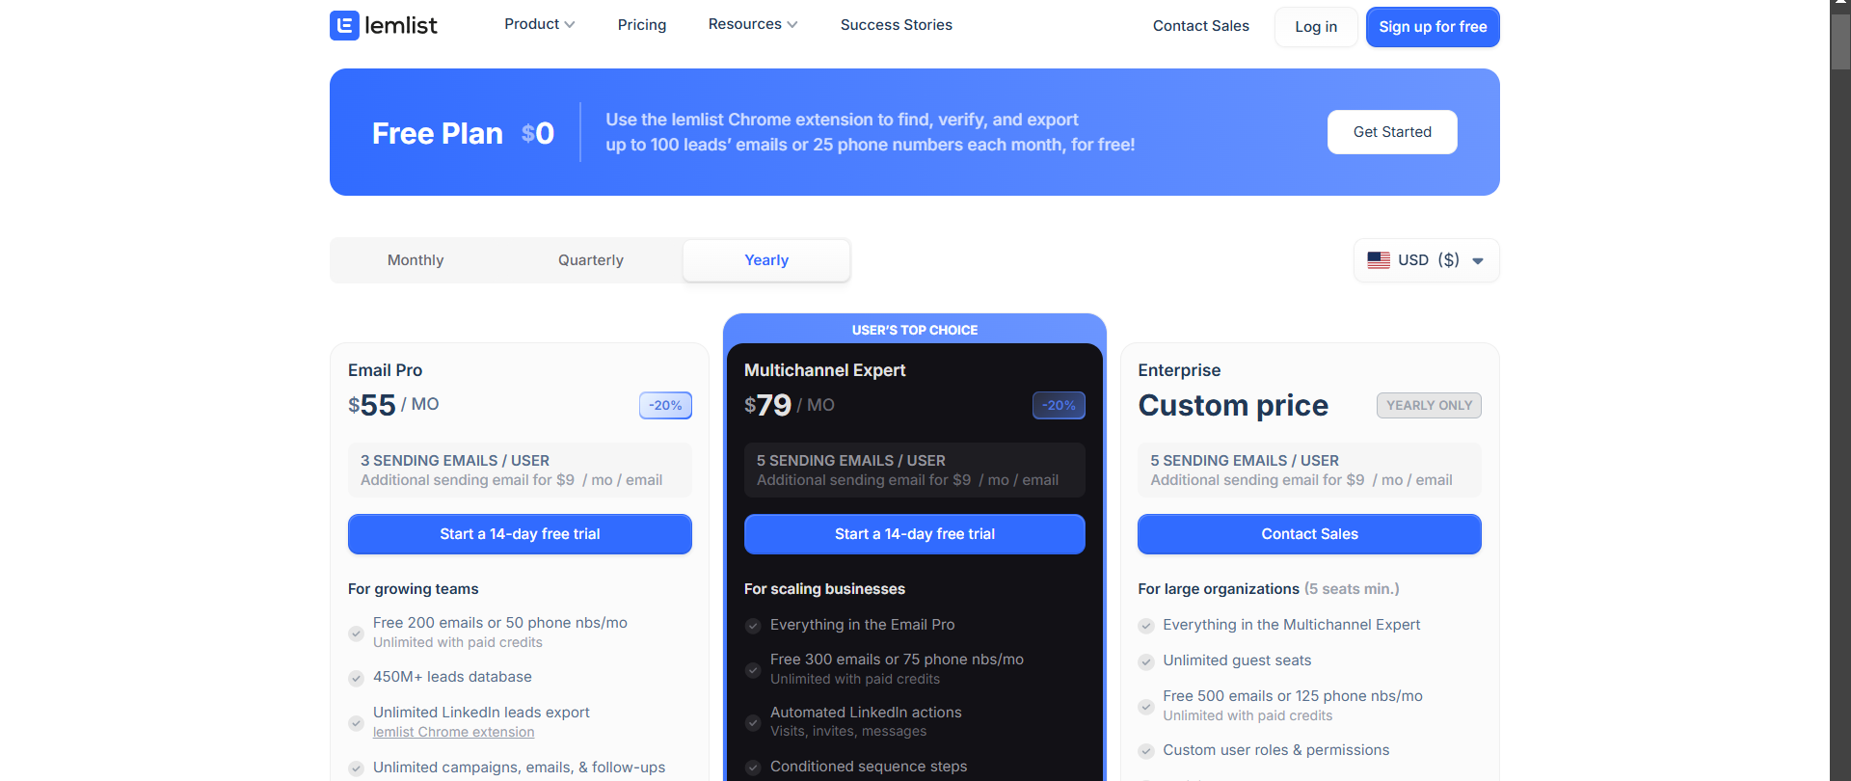

**What customers are saying:**“Lemlist made my cold emails stand out.Image Personalization = higher replies!”

**Limitations:**It’s not beginner-friendly. If you’re new to cold email, you might need to watch a few tutorials before you feel confident.

## 

## 

## 

## 

## 

## 

## **HubSpot**

Let’s talk about the big player in the marketing and sales world: **HubSpot.** Most people know it for its CRM, but it also has robust email automation capabilities? It’s an all-in-one powerhouse for managing leads, automating emails, and tracking performance.

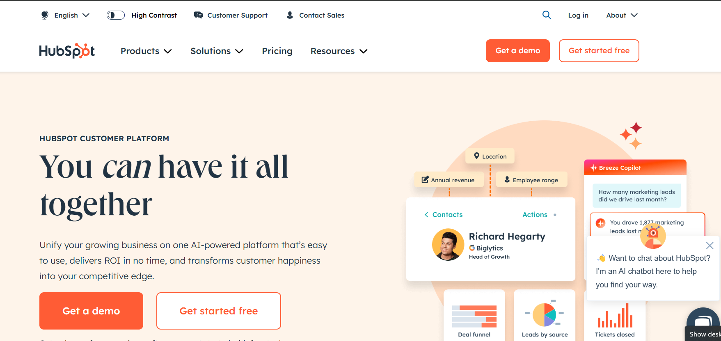

**What makes HubSpot amazing?**

* **Built-in CRM integration:** Since it’s a CRM first, it seamlessly ties your email campaigns to your sales pipeline.
* **Personalization features:** HubSpot makes it easy to tailor emails with dynamic content based on user data.
* **Automated sequences:** Create email workflows to nurture leads over time without lifting a finger.
* **Detailed analytics:** Track open rates, click-throughs, and even lead scores.

**Pricing:** HubSpot’s email automation starts at **$15/month** (Starter Plan) in the marketing product. If you need advanced features, explore more platform solutions, sales, services, and content.

Yeah, it’s pricier on the higher end with the professional and enterprise plans, but the features are worth it.

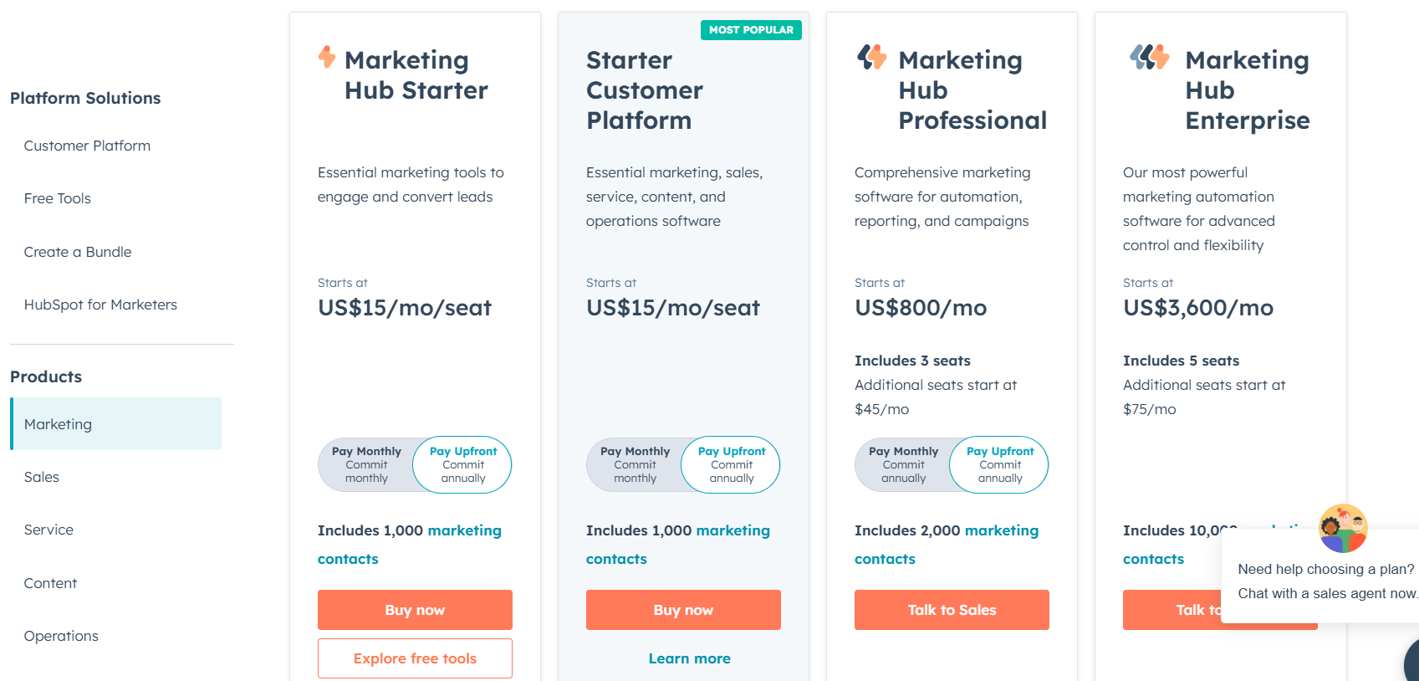

**What customers are saying:**“HubSpot is more than just an email tool—it’s our entire sales workspace . The integrations make everything run so smoothly!”

**Limitations:**HubSpot’s biggest drawback is its cost. For small businesses, the price tag can be a dealbreaker.

## **Mailchimp (and why it should not be used for cold email)**

Ah, good ol’ **Mailchimp.** This tool has been around forever, but it’s evolved into much more than a simple email marketing platform. It’s not a good choice at all for cold email automation, which is why I included it because I see so many of you making this mistake.

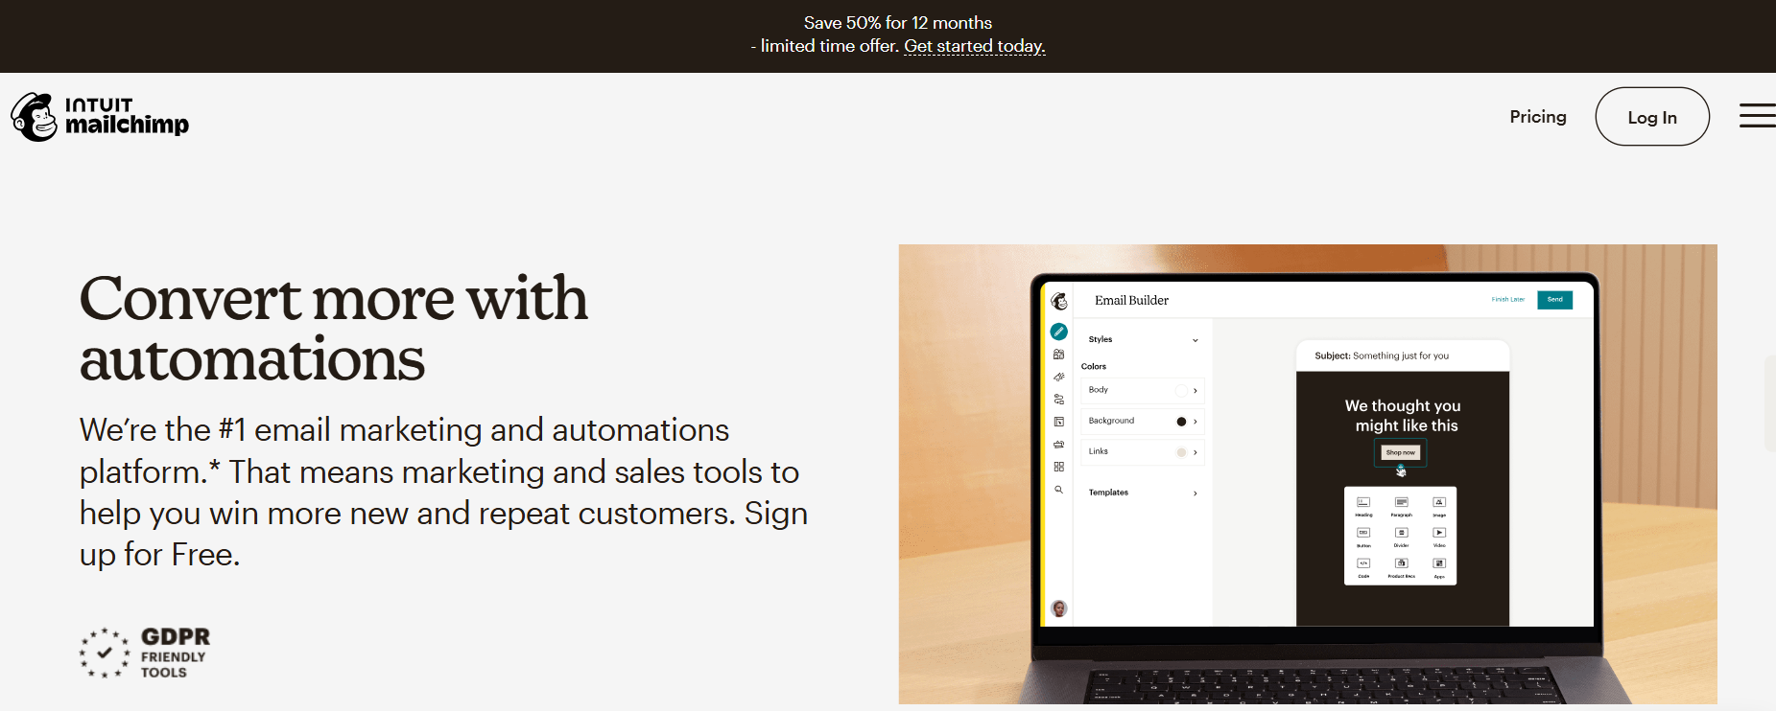

**Why Mailchimp is not a cold email tool ?**

* **Opt-in requirement:** If you’re sending cold emails, then you don’t have permission to send them cold emails (by definition of a cold email). Mailchimp will ban your account if you use them for cold email sending.
* **Shared IP:** If you send emails using Mailchimp, then your reputation gets tanked if there are other Mailchimp customers on the same IP adderss who are spamming. Your emails will land in spam too.
* **Marketing-like templates :** Your cold emails will look like they were sent using a mass marketing template.
* **Different send and “From” addresses :** An email you receive from Mailchimp has a different sender and From via address

**Standard Plan:**

* Send up to 6,000 emails per month
* 500 contacts
* Starts at $6.60/month for 12 months
* Then, starts at $13.20/month

**Premium Plan:**

* Send up to 150,000 emails per month
* 10,000 contacts
* Starts at $131.99/month for 12 months
* Then, starts at $263.97/month

**Note:** The pricing is for the first 12 months, after which the price increases.

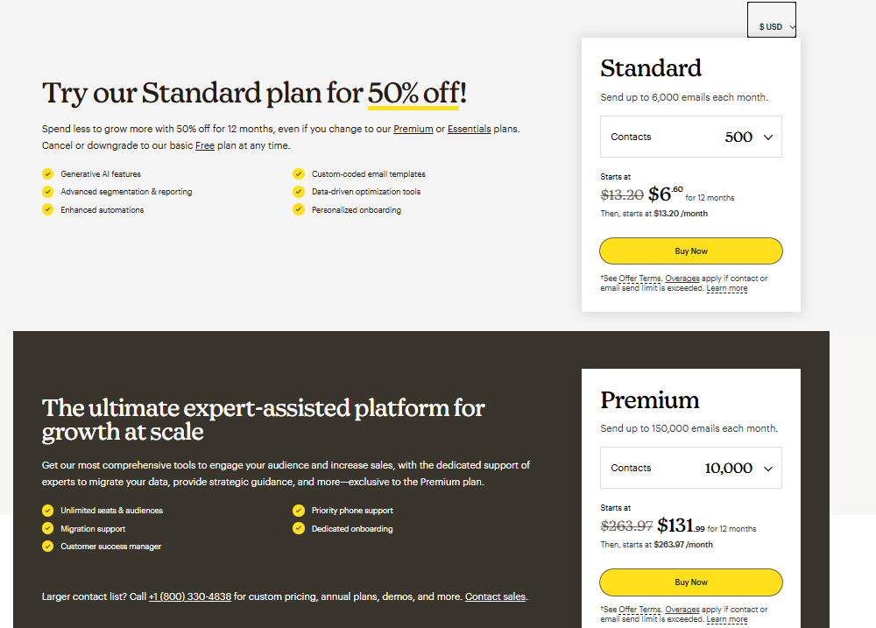

**What customers are saying:**“Mailchimp made our marketing emails look so professional! The templates saved us hours of work.”

**Limitations:**Mailchimp isn’t specifically built for cold emails, so deliverability for unverified lists can be hit or miss.

## **Snov.io**

Looking for a cold email tool that’s also got a solid leads database Say hello to **Snov.io.** This tool is perfect for scraping leads, building email lists, and launching targeted campaigns.

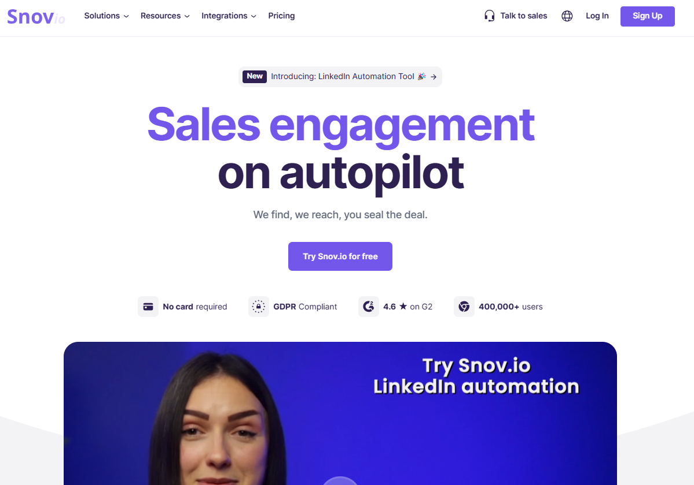

**What makes Snov.io unique?**

* **Email finder:** Find verified email addresses for your target prospects in seconds.
* **Cold email drip campaigns:** Automate follow-ups to keep your prospects engaged.
* **Lead tracking:** Monitor where leads are in your funnel and prioritize accordingly.
* **Browser extension:** Grab contact info while browsing LinkedIn or company websites.

**Pricing:** **Trial:** Free, with limited credits.

**Starter:** $30/mo, all core tools for steady sales.

**Pro:** $75/mo, unlimited sales and business opportunities.

**Managed Service:** Contact sales for custom pricing.

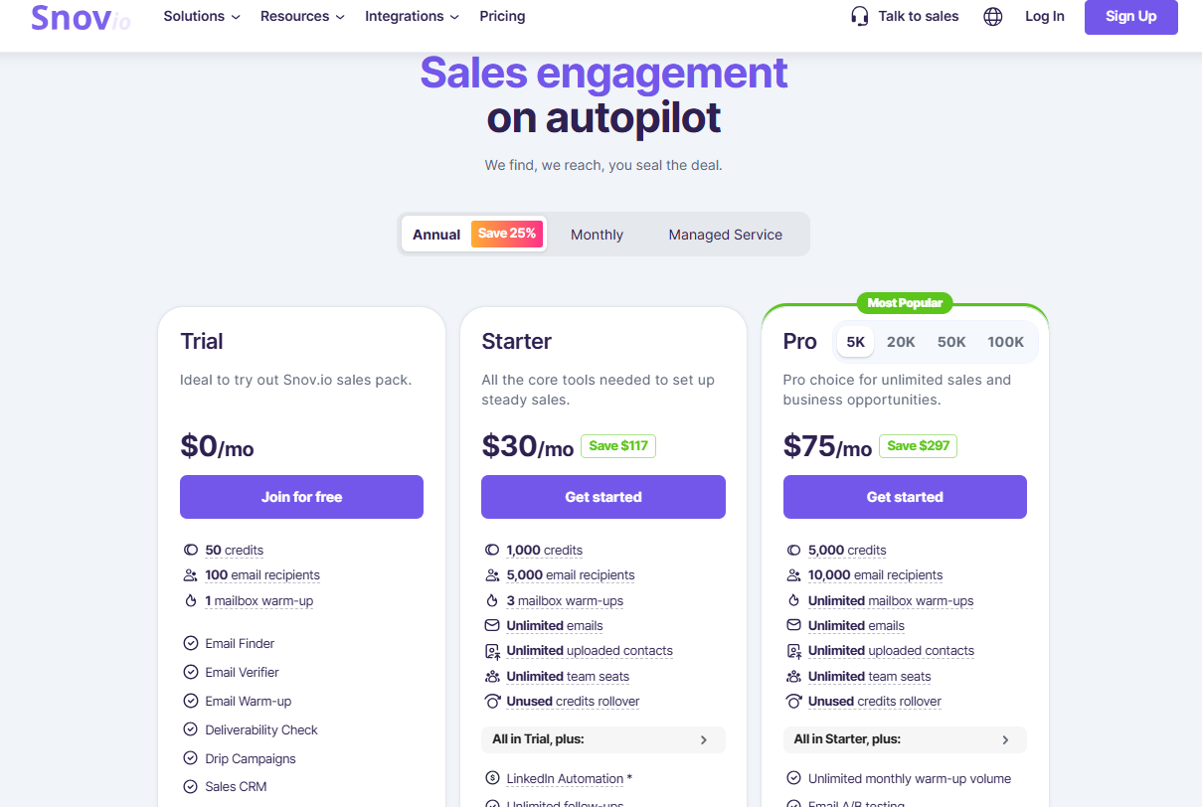

**What customers are saying:**“Snov.io’s email finder saved us hours of manual work. And their automation is just so simple to use!”

**Limitations:**The interface can feel a bit clunky at times. Also, beginners might find it hard to set up drip campaigns without a bit of guidance.

## **Klenty**

Let’s round off this list with a hidden gem: **Klenty.** This tool is built specifically for sales teams looking to scale their outreach. It’s simple, effective, and does exactly what it promises.

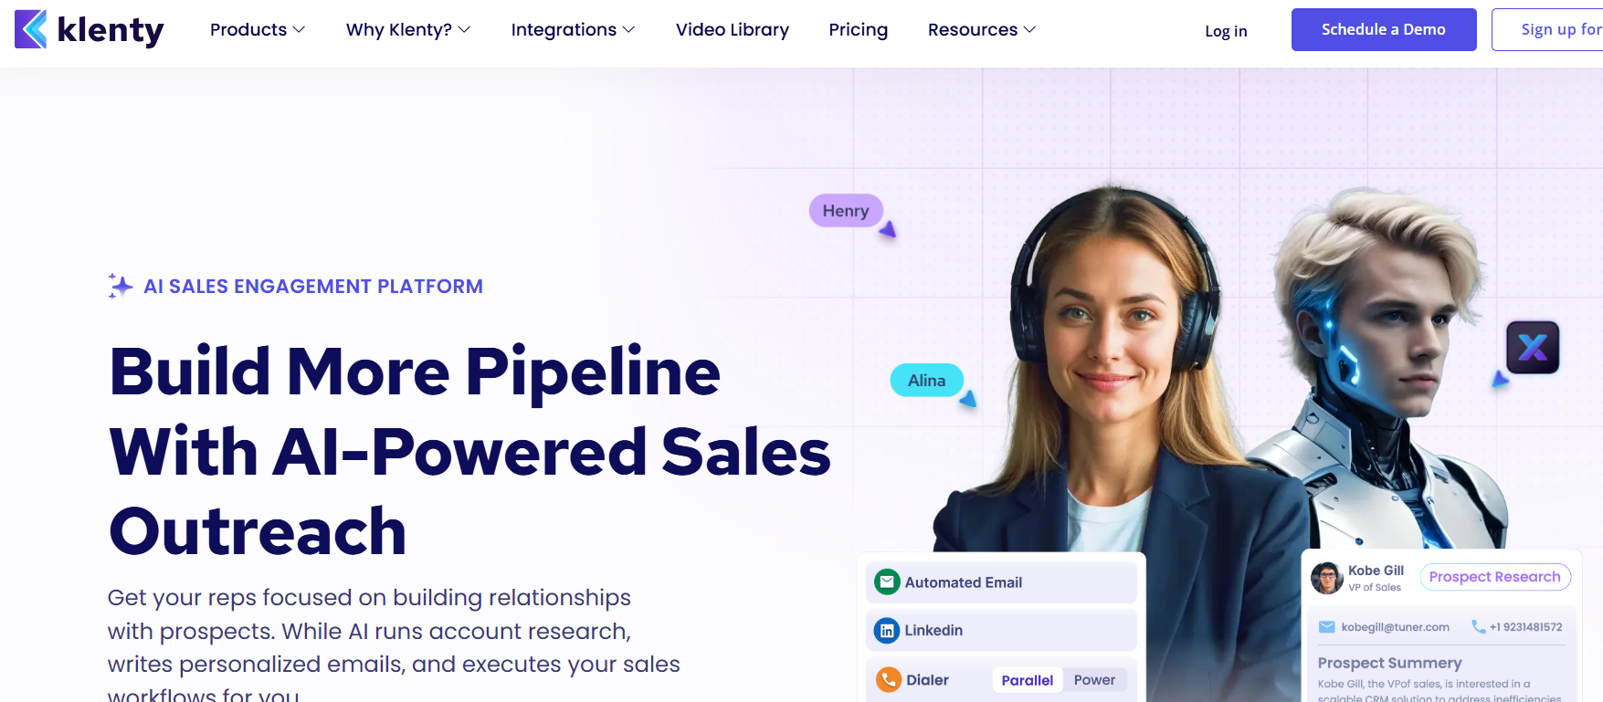

**Why should you consider Klenty?**

* **Automated follow-ups:** Never lose a prospect again! Klenty sends timely, personalized follow-ups based on user behavior.
* **CRM integrations:** Works seamlessly with tools like Salesforce, Pipedrive, and Zoho CRM.
* **Deliverability booster:** Keeps your domain and sender reputation squeaky clean.
* **Custom scheduling:** Choose the best times for your emails to land in inboxes.

**Pricing:** **Starter:** $50 per month (billed annually), ideal for personalized email outreach.

**Growth:** $70 per month (billed annually), for teams with a sales approach who need a clean and updated CRM.

**Plus (Popular):** $99 per month (billed annually), ideal for mature SDR teams looking to consolidate their outbound tech stack.

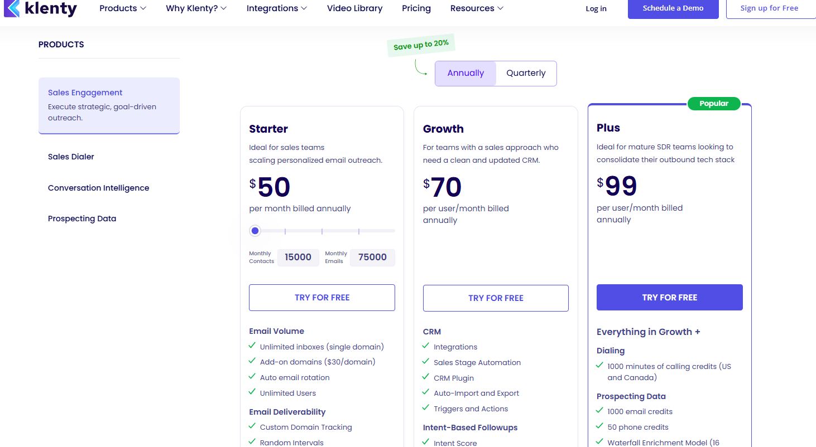

**What customers are saying:**“Klenty took the guesswork out of our sales outreach. The automation has freed up so much of our team’s time!”

**Limitations:**It’s pretty sales-focused, so it might not be the best fit for non-sales use cases.

So, there you have it—go ahead and add one of these tools to your cold email arsenal. By now, you’re probably thinking, “Okay, which one should I pick?” The answer depends on your goals, budget, and the size of your operation.

Here is our summary:

1. Pick Saleshandy, Smartlead or Instantly if you want a squeaky clean email automation tool with unlimited senders. But beware that cold email response rates are at an all time low (1%), and none of these tools have LinkedIn automation capabilities
2. Pick SalesRobot or Lemlist if you want solid LinkedIn automation capabilities along with email automation. This should net you about 5-10% reply rate.
3. Pick Snov io if you need a leads database along with cold email capabilties
4. Pick Woodpecker if you’re already using dux soup for LinkedIn automation cause they have a solid integration.
5. Pick Hubspot Sales Hub if you are already using them as your CRM
6. Pick Klenty if you have a sales team of at least 5 people
7. For the love of god, don’t pick Mailchimp for cold email.